Weekly QA Report – Login Page Testing Progress (Week 3)

Dear Arman,

I hope this email finds you well. I am writing to provide you with the QA testing report for the login page functionality during the 3rd week of our sprint.

Metrics:

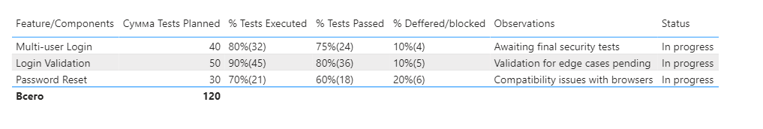

Best regards,

Khanzada

QA Engineer

DataArt